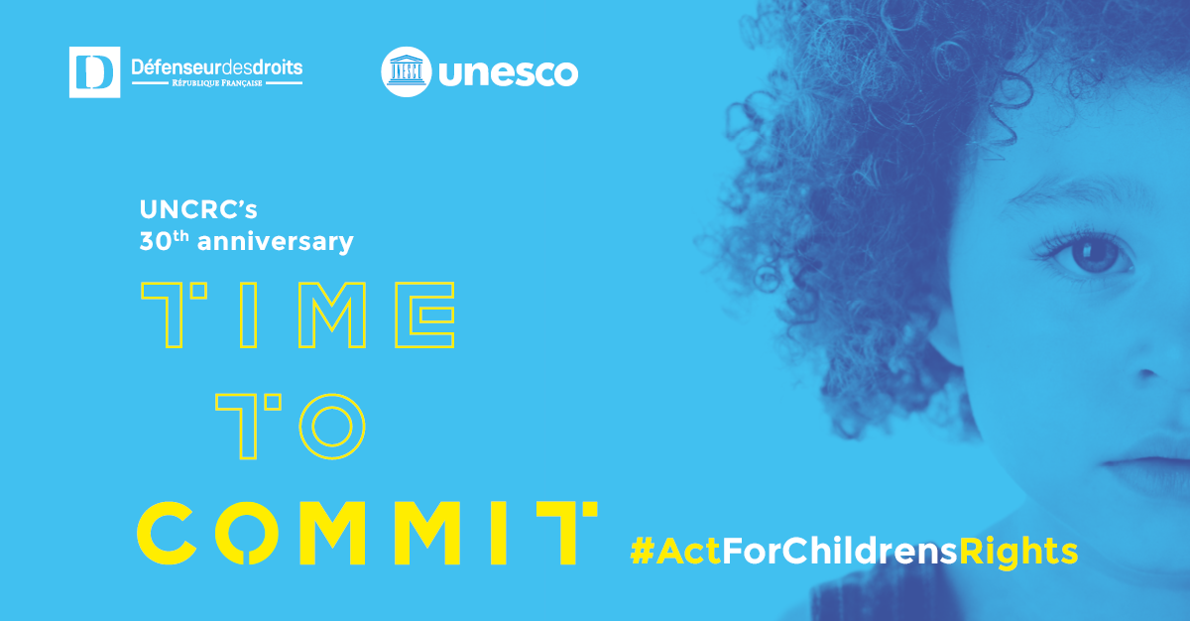
30th anniversary of the Convention on the Rights of the Child

The year 2019 marks the 30th anniversary of the adoption of the Convention on the Rights of the Child (CRC). However, despite being the most ratified international text in the world today, many children's rights still strive to be respected.

On this occasion, UNESCO and the Defender of Rights in France are organizing a joint event, moderated by Mélissa Theuriau, where the voices of children and youths will meet the voices of political leaders, experts and other committed actors, at the country and international level, around four themes:

- The right to education
- The right to participation
- The right to be protected against all forms of discrimination
- The right to protection against all forms of violence

Children and youth from the UNESCO Associated Schools Network in addition to those having participated in the French national consultation conducted by the Defender of Rights, "I have rights, hear me", will pose questions to decision-makers about the realization of their rights and share their proposals for the years to come.

Draft programme

Wednesday 20 November

UNESCO – Room 1
08:00 | Arrival of the participants
09:25 | - Welcome address: Ms. Melissa Theuriau, French journalist and moderator of the event  - Video on the Convention on the Rights of the Child
09:30 | - Opening address by Ms. Audrey Azoulay, UNESCO Director-General, and Mr. Jacques Toubon, Defender of Rights in France
09:34 | - Address of the President of the French Republic, M. Emmanuel Macron
10:00 | - Presentation by Melissa Theuriau
10:03-10:33 | Theme 1: The right to participation
Video of the national consultation "I have rights, hear me", conducted by the French Defender of Rights

Introduction
Ms. Geneviève Avenard, Defender of Children in France and Elsa Marignac, youth from the Advisory Committee
Questions
From children and youth of the UNESCO Associated Schools Network, Psychiko school, Greece (video)
From children and youth of the national consultation conducted by the Defender of Rights in France, group of the Institute of Human Rights of Caen
Answers
Ms. Anne Hidalgo, Mayor of Paris, France
Ms. Amal Aldoseri, Vice-President and Member, United Nations Committee on the Rights of the Child
10:33-11:03 | Theme 2: The right to education
Introduction
Ms. Stefania Giannini, Assistant Director-General for Education, UNESCO
Questions
From children and youth of the UNESCO Associated Schools Network, Aurore School Complex, Burkina Faso and Aljamia schools group, Jordan (videos)
From children and youth of the national consultation conducted by the Defender of Rights in France, “Ecole pour tous” (School for all) Collective
Answers
Ms. Kandia Camara, Minister of National Education, Technical Education and Vocational Training, Côte d’Ivoire
Ms. Koumbou Boly Barry, United Nations Special Rapporteur on the right to education
Mr. Gilles Pecout, Rector of the Ile-de-France Academic Region, Rector of the Paris Academy, Chancellor of the Universities of Paris, France
11:03-11:13 | Presentation of the Recommendations formulated by the group of associations Dynamique, Ms. Catherine Chabrun, Vice President of Defence for children international France  Song by Lomme school
11:13-11:33 | Theme 3: The right to be protected from all forms of discrimination
Questions
From children and youth of the UNESCO Associated Schools Network, American International School, Costa Rica (video)
From children and youth of the national consultation conducted by the Defender of Rights in France, National Association of the Councils of Children and Youth
Testimony of Grands Corps Malade, French slam poet, lyricist and film director
Answers
Ms. Laurence Rossignol, Parliamentarian, France
11:33-  12:03 | Theme 4: The right to protection against all forms of violence
Question
From children and youth of the UNESCO Associated Schools Network, 31st school, Mongolia (video)
Answer
Mr. James O'Higgins Norman, UNESCO Chair on Tackling Bullying in Schools and Cyberspace, Dublin City University, Ireland

Question
From children and youth of the national consultation conducted by the Defender of Rights in France, association “Grandir dignement” (grow up with dignity)
Answer
Mr. Adrien Taquet, Secretary of State attached to the Minister for Health and Solidarity, France
12:03 | End of the plenary session with Melissa Theuriau and Grand Corps Malade

